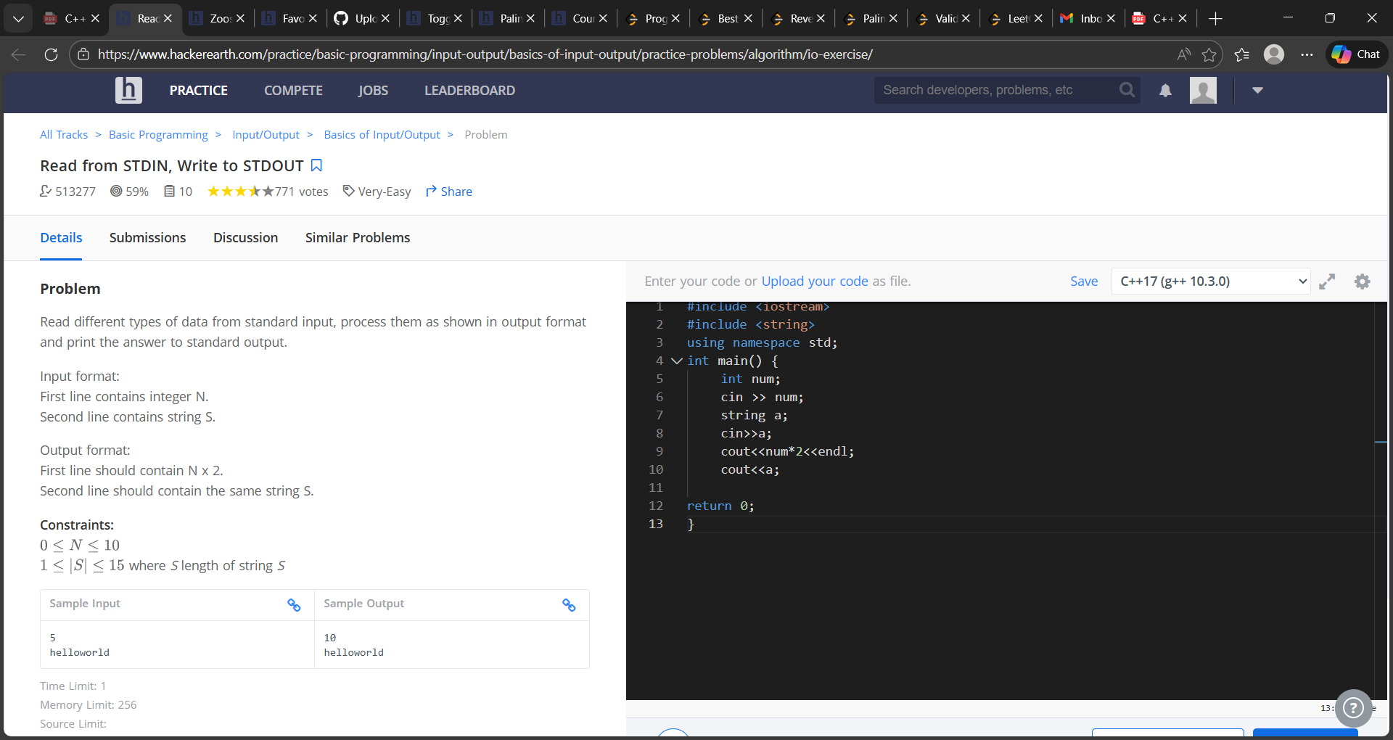
Efqf4g2

#include <iostream>
#include <string>
using namespace std;
int main() {
int num;
cin >> num;
string a;
cin>>a;
cout<<num*2<<endl;
cout<<a;
return 0;
}

